**IMPLEMENTATION USING REMIX IDE**

**STEP 1**

* + Open the REMIX IDE

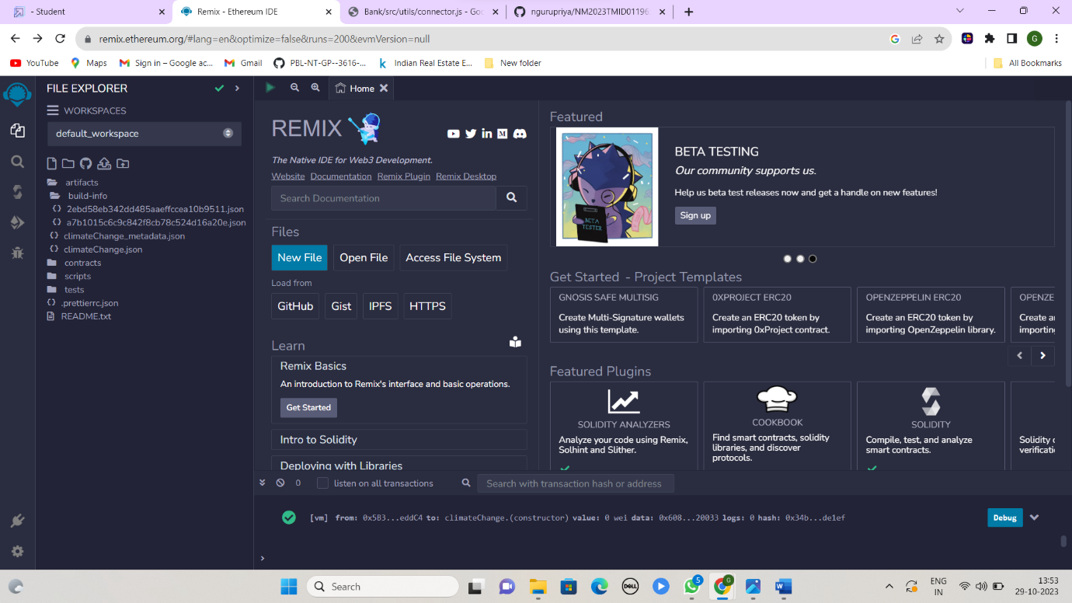

**STEP 2**

* Create the new file

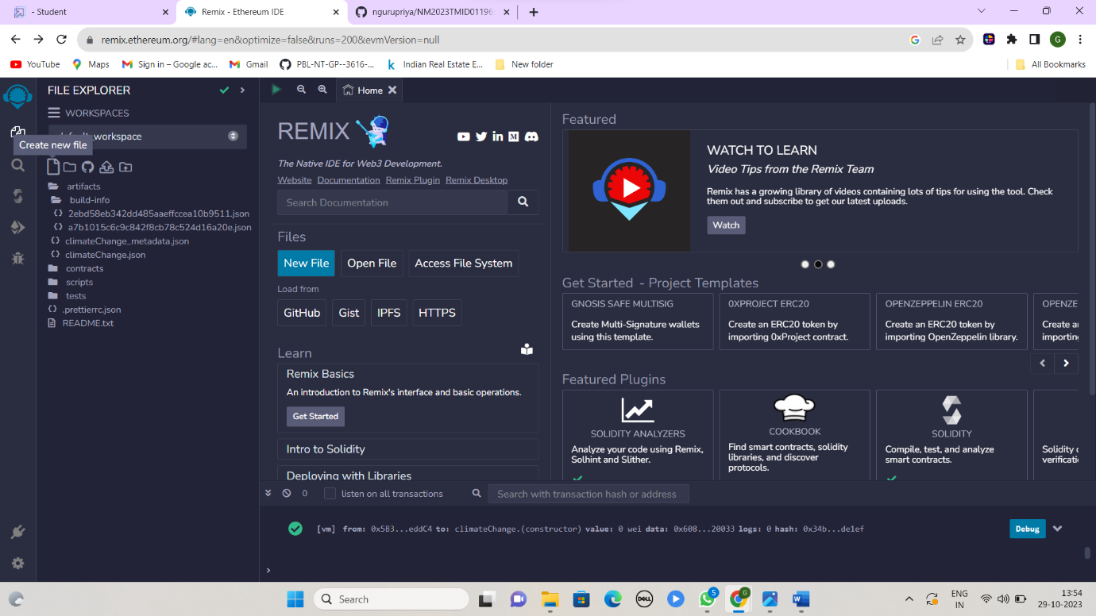

**STEP 3**

* Open the created file

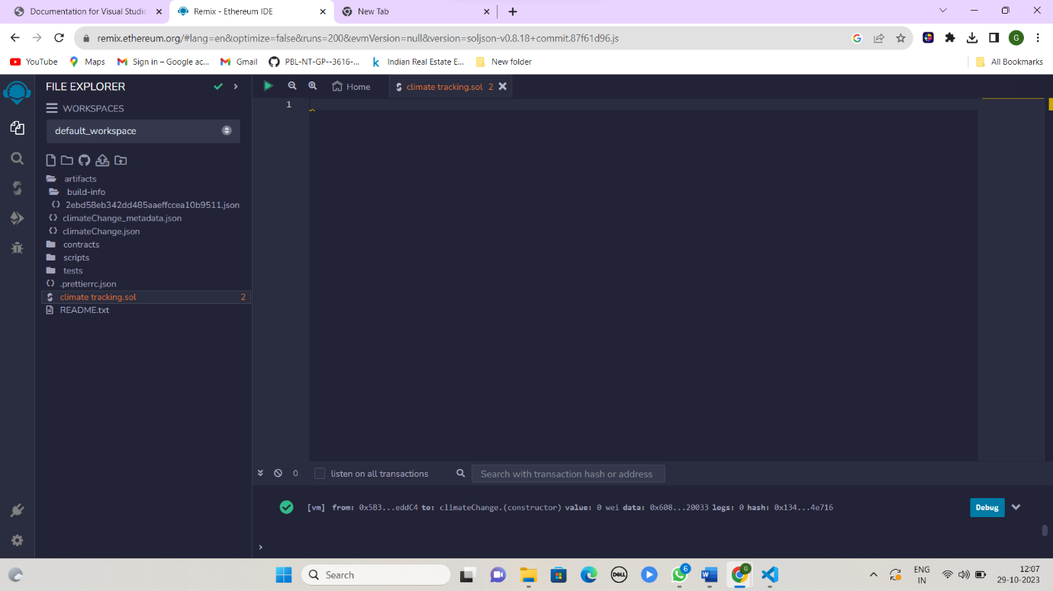

**STEP 4**

* Implement the code

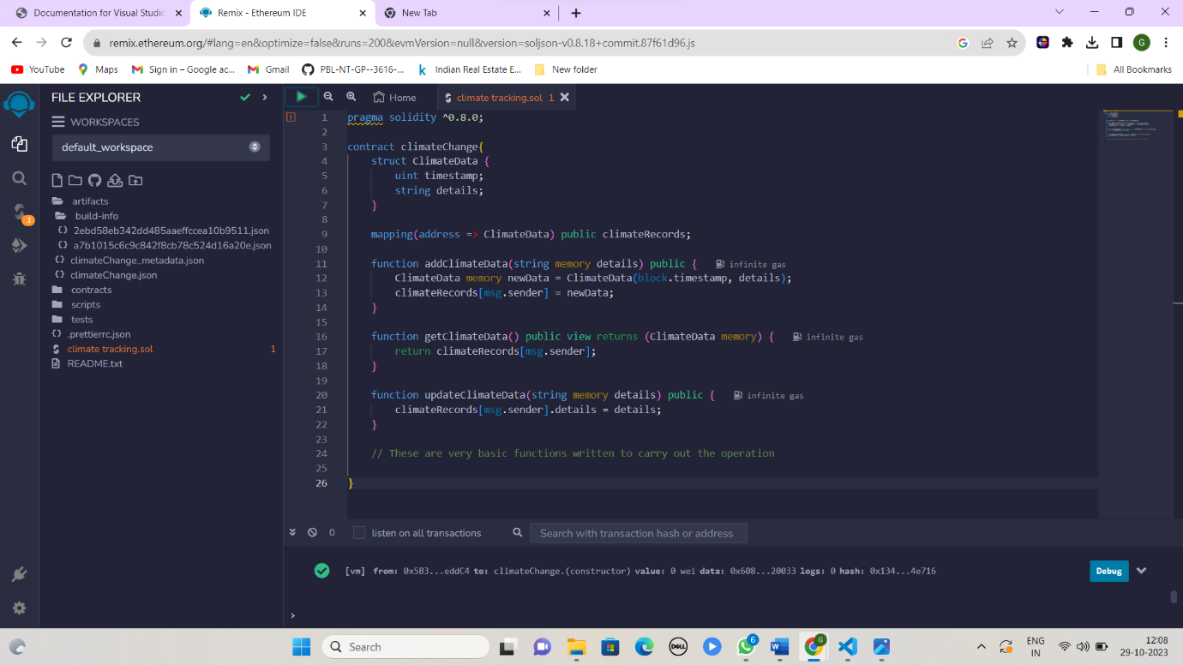

**STEP 5**

* Compile the code

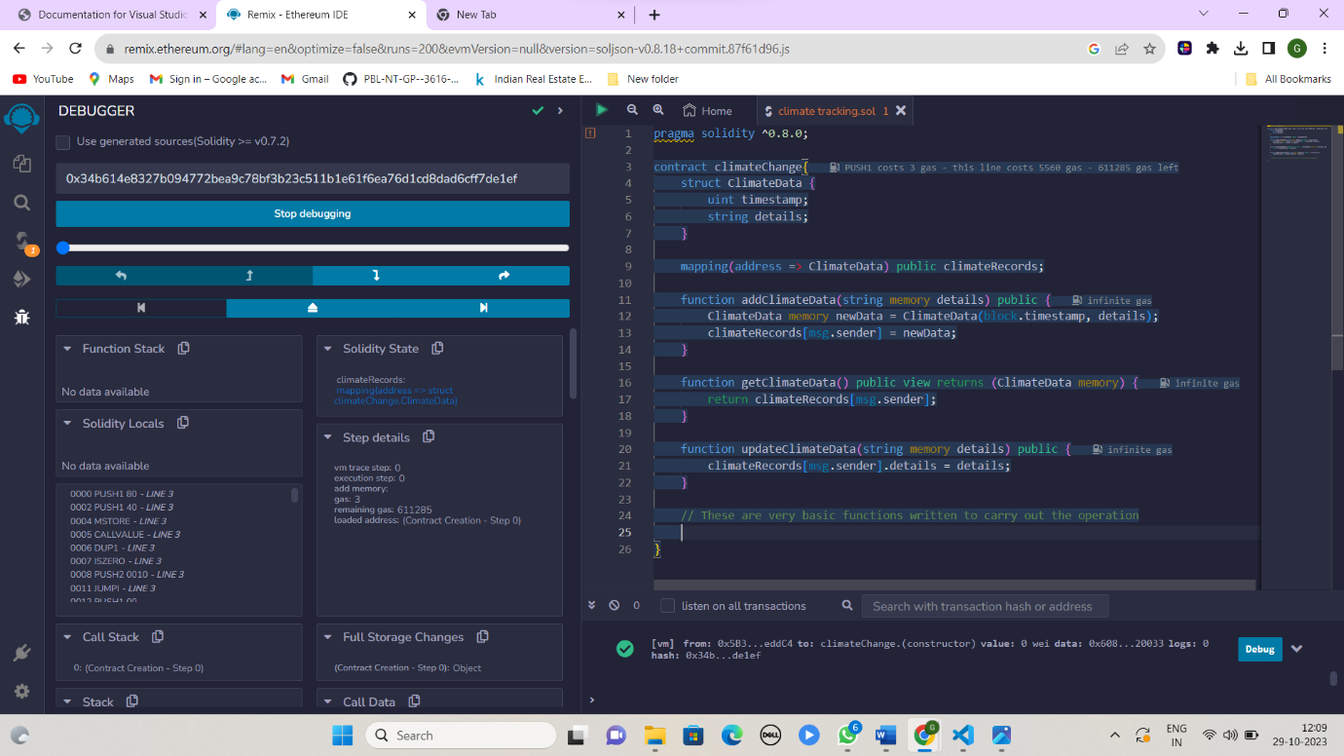

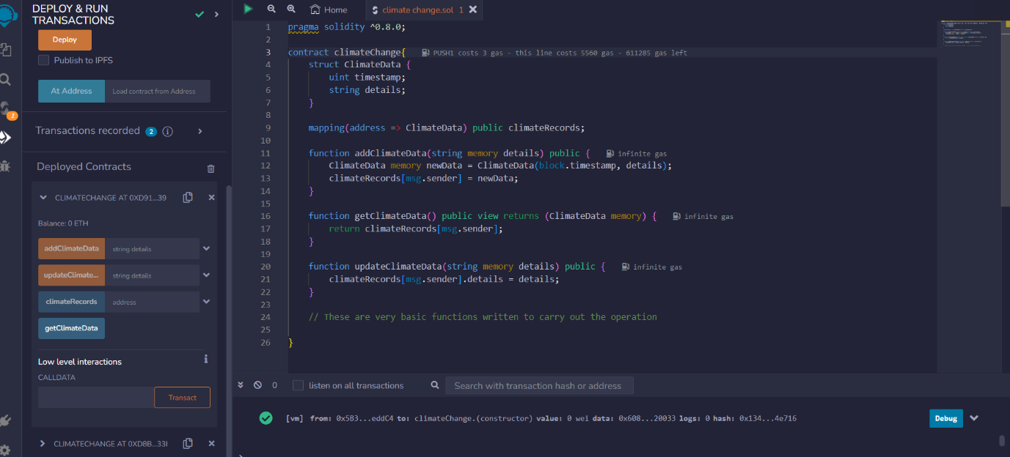

**STEP 6**

* OUTPUT

